Guidelines for Turnitin Plagiarism Tool Account Set up
Step 1 -> Students will receive an Email for setting up their Turnitin Account. Open the email and click on "Set up account"

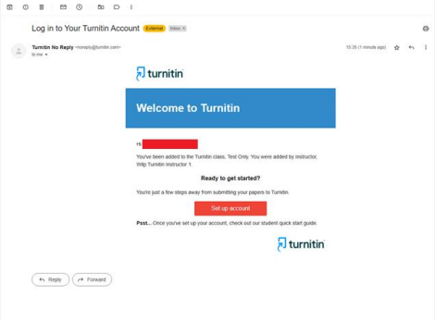

Step 2 -> In order to set up your account, please enter your BITS Student email id in "Email Address" and enter last name as dot (.) in "last name".
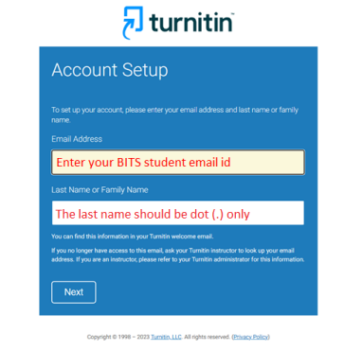

Step 3 -> After completing step 2, you will receive an email on your BITS student email id for validating your account. You need to complete this validating account activity within 24 hours to set up your Turnitin account.
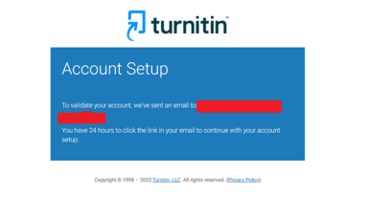
Step 4 -> Once the above steps are done, you will receive another email for creating your Turnitin password for your account. Open the email and click on "Create Password"
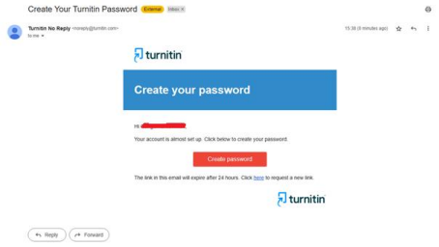

Step 5 -> Once the above step is completed, you will be taken to the Account Setup Completion page. Click on "Log in"
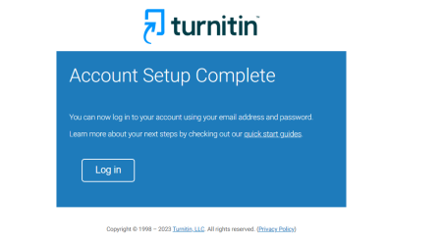
Step 6 -> Enter BITS student email id in "Email Address" & Turnitin password to login
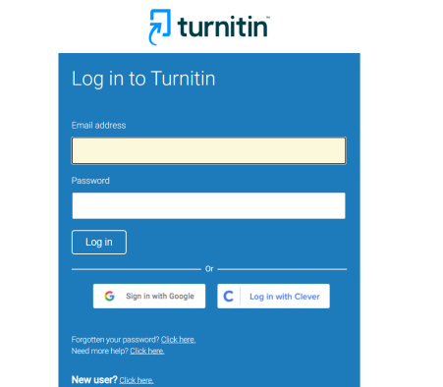
Step 7-> Once you are logged in, your email, first name (Student Id) and last name (.) will be displayed in the Welcome to Turnitin page.

Select the "Secret Question" and accordingly input the answer in the "Question answer" box and click on "Next"

Please don’t change the (Student Id) to your (Name) and last name. Kindly go to next only.
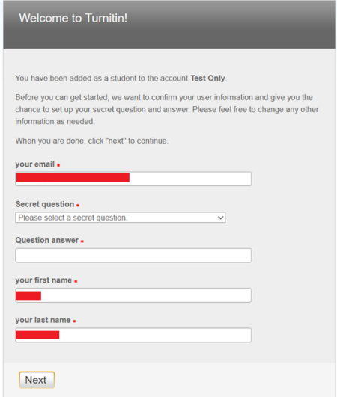

Step 8-> In the User Agreement page, click on "I Agree -- Continue"
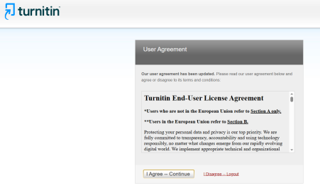
Step 9-> On completion of the above step, students will be taken into their Programme Class. Click on the Class name appeared under "Class Name"
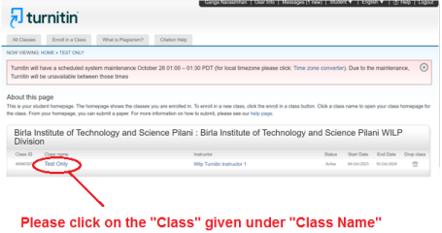

Step 10-> Click on "Submit"
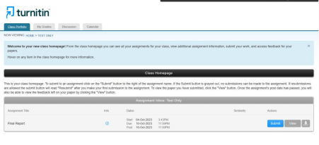
Step 11-> On clicking the "Submit" button, students will be taken into the Single File Upload page. Under "Submission title" the submission title should be entered. The submission title should be entered as BITS Student ID in small letters.

For Example, If a student's BITS ID is 20191BT577, then the Submission title can be named as 201918bt577
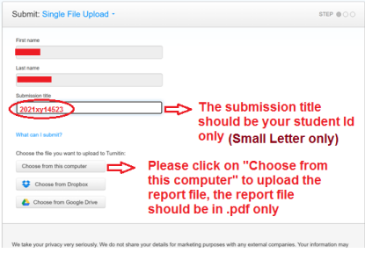

Step 12-> After uploading the report file in .pdf format, Click on "Confirm"
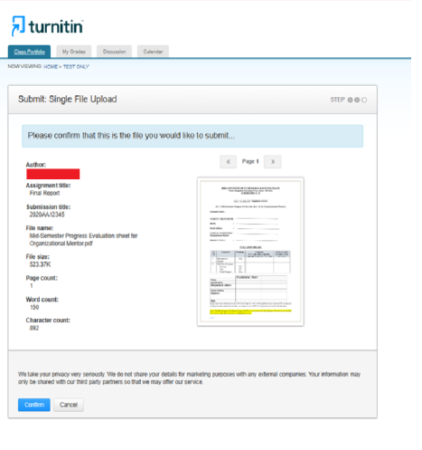
Step 13-> Please read the message and if it is successfully uploaded, kindly click on "Return to assignment List" as shown in image below.
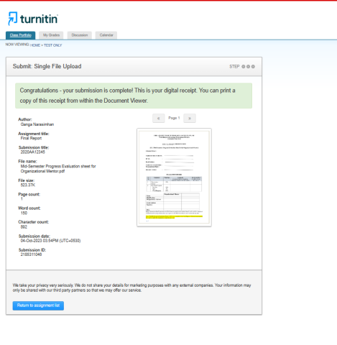
Step 14-> The next page will display the Plagiarism % for the submitted report. If the report similarity index is higher than the permissible limit of 20%, students have to rework and change their report content and "Resubmit" the report again before the given due date. Once you upload an updated report, the already submitted report will be replaced with a newly submitted report.

Plagiarism must not exceed 25%. Faculty will consider the Student Report for Evaluation only if the Plagiarism % is within the permissible limit of 25%.
